1 What is angular?
==>angular is a open source,most popular widely used javascript framework .wich developed by google developer.
Angular is mainly used for Front end development.
Angular are used to make single page , interactive , user friendly web application using html and typescript.

2 What is angular CLI ?
==>Angular cli is a command line tool that allows us to add multiple components,directives and services to the command line.
Angular cli is mandatory for creating angular application.

3.what are building block of angular ?
==>components,services,pipes,decorators,directives,data binding,metadata etc.

4.what is template in angular ?
==>Angualr template are written with HTML that contained angular element and atribute.
Angualr template are use to render the view in the browser like html but it has more functionality
the template elements tell angular how to render the html on the screen using program logic and data

5.What are the Angualr Feutures
==>1 .Two way data binding=>
angualr allows us two way data binding controller to view and view to controller.

2.MVC Architecture =>
MVC stands for model view controller .The application data and logic manage by model .View are use to visualize data to user . and controller make a connection betweeen model and view. Controller controll data flow into a model and updates the view whenever any data changes
3. cross platform
4 lazy loading
5 two way data flow
6 Angular Cli=>
angualr provide command line tool so that why we can aesily add components ,services,modules in our application.

6 Advantages of Angular
==>1 it support two way data binding.
2.it follow mvc pattern architecture.
3.validations are supported.
4.dependancy injections support
5.has strong feature like event handling and Animation
6.High quality of application
7.improve speed and performance
8.Readable and testable code
9.cross platform development.
10.support static and angualr template

7.diff between angular 12 and angualr 13 ?
==>
Angular 12 | Angular 13
It use typescript 4.2 | It use typescript 4.4
Improved component test harness | Improve to angular cli
improvement http | Component api update

8.What is Data binding?
==> Data binding is most important and powefull feature that allows us to communication between components and DOM.
In angualr there are 4 forms of data binding
1.String interpolation
2.Property binding
3.Event Binding
4 Two way Data binding

9.What are Angular Modules
==>Angular modules is a container which hold group of components ,pipes,deirectives and servises wich are related to the application.
Modules make code become more maintainable ,testable,and readable also.
All dependancies of your application are generally defined in modules only.

10.What is Subscribing in Angular ?
==>In angular we use subscribe() method to subscribing .
Wich is use to connect the observer to observable event.
Whenever any changen is made in these observable then code is executed and produce result and changes using this subscribe method .
Subscribe() method takes three functions as a parameter.
1.next()==>its required method .use to handles all delivered value.this method is callled zero or more time after execution start.
2.error()=>it is optional method.wich is use to handle error notifications.
3.complete()=>it is optional method.wich is use to handle execution-complete notification.

11.What are different types of filter in Angular ?
==>Date,Filter,Json,uppercase,lowercase,number,orderBy

12.What is dependancy Injection In angular ?
==>dependancy injection are use in a services.when we need to inject any service in our coponents then we use dependancy injection
dependancy injection is a design patturn in angular .in wich class request dependancies from external sourses rather than creating them.
Angular dependancy injections are use to increase flexibility and modularity in your application.

13.What is diff Between one way and two way data binding
==>
One Way | Two Way
Data flow from model to view | Data flow from M-to-V and V-to-M
To achive one way data binding use propety binding,string interpolation in angular | To achive two way data binding we use ngModel .
In this data flow from TS file to HTML file | In thid data flow from TS to html and html-to ts file

14.What is Transpiling in Angular ?
==> Transpiling is the process to convert source code from one programming language to another .in angular this process is done from Ts file to Js file ,but its happen implicitly or internally.

15.What do you understand by REST API in angular ?
==>its stand for restfull application Programming interface
Rest Api is work on http request.
Its allows us to request http to perform any operation.
There are multiple methods such as get() post() put() delete() to perform operations.

16 .What is eager and lasy loading ?
==>1 Eager=> eager loading is loading moduls before application start.
Its loading all components ,moduls and other data when application is loading .

2.Lasy ==> lasy loading is loading module when deamand.
Lasy loading is the process of loading components,modules and other data when they are required.
Its improve application performance .

17.What is Directives in Angular ?
==> directives are classes wich is used to add additional behaviour in our Apllication.
Angular directives use to manage forms, list styles etc.
Therer are three types of directives
1.structural directives ==>
structural directives are directives wich change the structure of the DOM by adding and removing elements . There ate three im-built structaral directives . ngIf,ngFor,ngSwtich extc .
2. Attribute Directives ==>
wich is use to change the behaviour of an element, component and another directives. Ex ngClass ,ngStyle

3 Componnets directives==.
This directives are used in a main class. That contain the details of how componnets should be processed, and used at run time.
All components are directives but not all directives are componnets.
It is used to specify the html/template for the dom .

18.Diff between constructor() and ngOnInit()

Constructor | ngOnInit()
It is a part of javascript class | It is a part of angular lifecycle
It is used for injecting dependancy into class | Actual business logic perform in this method
its called by javascrip enjine | Its called by Angular

It is automaticaly called at a time of object creation. | Invocked by angular when component is initialized
Not everything in component to initialize at the time of invocation | Everything is ready at a time of invocation

19. What is Services ?
==> services helps you to share common logic or Data ,functions overall Angular application.
Service contains method that maintan data throughtout the life of our application.

20. Diff between Observable and Promise ?
==>
Observable | Promise
Emit multiple value over a period of time | Emit a single value
Its lazy >its not execute untill we subscribe to them using subscribe() method | Not lazy> execute immediatly after creation.
It can cancle subscription using unsubscribe() method | Are not canclelable

Provide map, foreach,reduce methods | Dont provide any opreation

21. What is interpolation ?
==>interpolation is a technique that allow the user to bind value to a UI element. Interpolation binds the data one way.

22.What are Routing in angular ?
==> Routing are use to navigate from one page to another .
By using angular router we can move multiple view in our application without refreshing page.
Routing play most important role to create single page web application.without routing we cant create single page application.

23. Forms in Angular ?
==> there are two types of forms available in Angular
1.Template driven form
2.Reactive Form

24 What is difference bett template driven form and Reactive form.
==>

Template Driven | Reactive Forms
Its need the formModule | Its need ReactiveFormModule
Two way data binding | No data binding
Maximum template code | Maximum component code

Not easy for Unit testing | Its easy to unit testing

25. Event loop
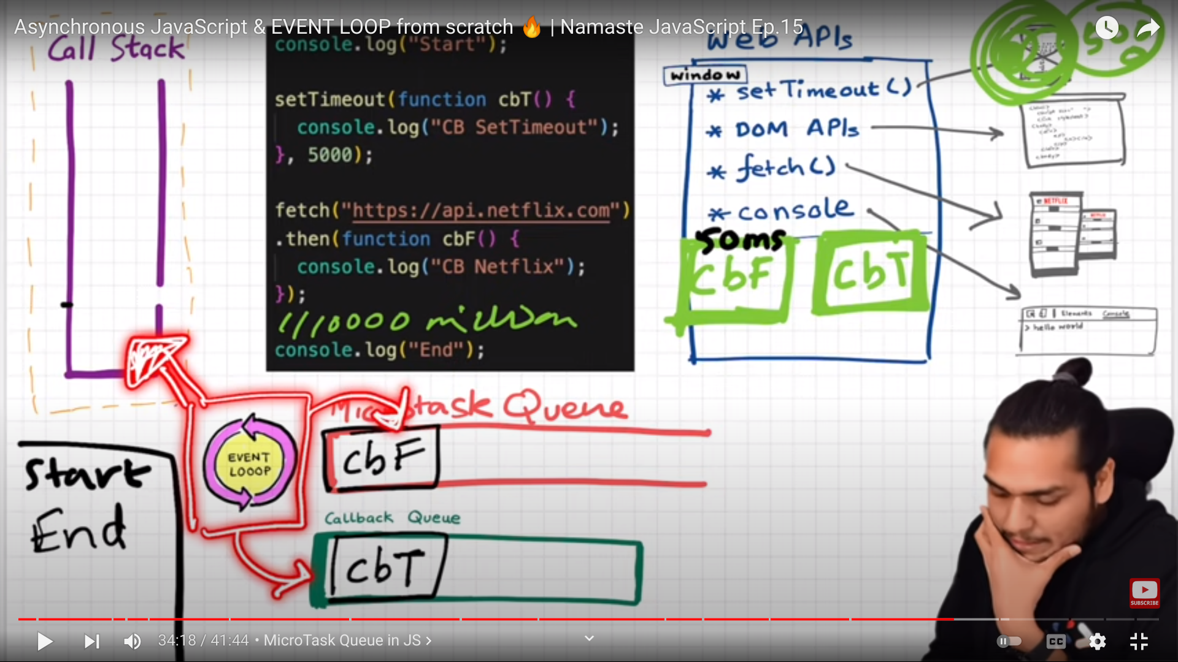
==>

26.Template Reference variable ?
==>
<label>first name</label>
<input #firstName/>
<br>
<label>last name</label>
<input #lastName/>
<br>
<button (click)="showdata.innerText=firstName.value + ' '+ lastName.value">
Click me</button>
<br><br>
<span #showdata></span>

27. what is safe navigation operator(?.) ?
==> wich is use to avoid exception for null and undfined value.

28.Angular Life cycle Mothod ?
==>There are several life cycle method in angular .

1 .ngOnChange()=>
this method is called before ngOnInit(). This method is called when any data change in input property.

2.ngOnInit()=>this method is use to initialize componet and set input properties in our componets. This method is called only one time .in this method we use actual logic .

3 ngDoCheck()=> this method is always call after ngonChange() when any data change in our component.
It is called evry time when our any data is rerender.

4.ngAterViewInit()=>
this method is called when angular successfully initialize of parent and child component.

5 ngOnDestroy()=>
This method is called before angular destroy component and directives.
This method perform clenup operation ,using this method we can avoid the memory lickage problem.

29. What is decorater on angular ?
==>Decorater are design patturn.
Decorater are use to seperate modification and decoration of a class without modifying original source code.
Decorator start with @symbol.

There are four types of decorater in angualr -
1 class decorator. ==>@ngModule,@component
2 method decorator.==>@hostlistener
3 parameter decorator.==>@inject
4 property decorator.==>@Input,@Output

30. How angular Application load internally
==>index.html.=>script tag=>main.ts=>start bootstraping =>mgmodule file=>check all dependancies and load app component=>app.comp.html =>app root component

31.what is a observable ?
==> Observable are use to perform usyncronous opreration in angular.
Observable provide support between publisher and subscriber for data sharing in angular application.
Observable are works like promisses. But observable can emit multiple values at a time .
Observable use subscribe method for subscribing data .and use unsubscribe method for unsubscribing data.

32.What is RXJS ?
==> RXJS stands for Reactive extension for javascript.
this is javascript library wich allows us to work with asyncronous data stream.
RXJx library use obervables to make asyncronous and call back based code.
It is standalone javascript library that give access to programmmers to the observable.

33.what is an ng-template ?
==>ng template is an angular template .wich is use to render html in template.
Ng-template is the example of structural directives.
We can use ng-template based on the if-else condition.

34. what is httpclients ?
==>http client are used in a services.
Http client are used to send request and get response.
We need to import http cinet from @angualr/common/http module.
Http client have multiple methods to perform operations
get(),post(),put() delete().etc.
It return the observable and we need to subscribe it.

35.what is enum in ts ?
==>it is non primitive datatype .
enums allow a developer to define a set of named constants.
We declare enum variables using enum keyword.
Typescript provide both string and numeric base enum.

36.What is AOT compiler ?
==>AOT stands for Ahead of time compiler .
Aot compiler convert our angular html, and typescript code into javascript code during the build phase before browser run that code . So browser not need to download the compiler and compile the code . In this method browser can easily render the application by just loading already compiled code.

37. Diff between JIT and AOT compiler ?
==>
JIT Compiler | AOT compiler
Load the application sloweley than AoT ,it needs to have compile the application when running first time | Load the page more quickly than JIT compiler .
It download the compiler the compiles the application before displaying | It does not need to download the compiler .aot already compiles the code at a time of application building.
In jit compiler source code includes the compiler code also so bundle size will be higher | The Bundle size is less than Jit compiler
It is suitable in development mode | It is suitable in production mode
It use following commands ng serve ,ng build | It use following commands ng build –aot ,ng serve --o

37 How many ways we can communicate components
==> 1 @input() decorator;
2 Output() decorator;
3 local variable ;
4 viewChild()
5 service()
6 Using routing

38 Diff Between Pure And Impure Pipe
Pure | Impure
Pure pipe only called when angular detect the changes in the value or paramenter passed to pipe. | Impure pipe called every change detection no matter whether value or parameter change.
It works only when the component is Loaded | It works for every change inthe component .

39 Diff between shallow and Deep Copy
Shallow | Deep
It copy memory address of element | It copy exact value of element

ex.let obj1={name:'yogesh',skill:{
ps:"java", ss:'angular'
}}
let obj2=JSON.parse(JSON.stringify(obj1));
or let obj2=lodas.cloneDeep(obj2)

obj2.skill.ss="react"
console.log(obj1)
//{ name: 'yogesh', skill: { ps: 'java', ss: 'angular' } }
console.log(obj2)
// { name: 'yogesh', skill: { ps: 'java', ss: 'react' } }

40 Interface ?
- Interface are use to declare the types of variable, functions etc.
We can create interface using interface keyword.

41 Intersepter ?
== >intersepter is a angular service wich is use for intersept all the request and response call and modify them as per our requirement.

42 , Auth Guard/Route Guard ?
== > Auth guard are use to perform Autherization in angular application.
Auth guard are use to protect the route from unauthrized access.
Its prevent the users to navigating to parts of our application without authorization.
It is use to secure route path
We can create guard by using cli commands ng g guard guard name .

43 RXJS Methods ?
== >1. Of()=>It converts arguments to an observable sequence. e.g =of(1,3,5,7,4) ;
2. from() =>create observable from an array, string and promise.

